

**Al-Imam University Computer**

**Science Department**

**College of Computer and Information Sciences**





**Educational App-like Game**

**Team (FKR)**

December 30, 2023

| **Team (name)** | |
| --- | --- |
| **Team Member** | **ID Number** |
| Abdulrhman Abdulaziz Almuhanna  Hatem Khaled AlHarbi  Ali Abdulrahman Alkhalifah  Abdullah Abdulaziz Alwehaibi  Motaz Mohammed Alghamdey | 443016170  441017492  443015900  442015909  444012369 |

*Table 1 Team Members*

**Instructor:** Dr. Ibrahim Abdulmonem

**Section:** 171

**Table of Contents**

Phase one……………………………………………………………………………………3

1. Project Description
   1. Purpose…………………………………………………………………………………….
   2. Product Scope……………………………………………………………………………...
2. Overall Description
   1. Product Perspective……………………………………………………………………….
   2. Product Functions………………………………………………………………………….
   3. User Classes and Characteristics………………………………………………………….
   4. Operating Environment…………………………………………………………………...
   5. Design and Implementation Constrains………………………………………………….

2.6 Assumptions and Dependencies…………………………………………………………..

1. User Interface Prototype

3.1 User interface………………………………………………………………………..

1. Functional Requirement & Nonfunctional Requirements
   * 1. Functional Requirements…………………………………………………………
     2. Non-functional Requirements……………………………………………………

Phase two……………………………………………………………………………………8

1. System Models
   1. Context Diagram………………………………………………………………………
   2. UseCase diagram……………………………………………………………………..
   3. Sequence diagram……………………………………………………………………..
   4. Class diagram………………………………………………………………………….
   5. Activity diagram………………………………………………………………………
   6. State diagram…………………………………………………………………………..
2. User Interface Prototype
   1. User interface…………………………………………………………………………..
   2. Login interface…………………………………………………………………………
   3. Levels Interface………………………………………………………………………..
   4. Game interface…………………………………………………………………………

*Phase one*

1. **Project Description:**
   1. **Purpose**

**This document describes the software requirements and specifications of the website. The purpose of the app, The purpose of the app to improve Children and teenagers interested in learning and improving arithmetic skills.**

* 1. **Product Scope**

**This product is an educational app enables the students to Provide an entertaining educational game that enhances understanding and application of basic arithmetic operations, In level progression upon solving problems correctly, And Multiple levels with increasing difficulty.**

1. **Overall description:**
   1. **Product Perspective**

* **This app is a new standalone app that provides functionality described in the product functions section. It includes all needed to fulfill these software requirements.**
  1. **Product Functions**
* **Interactive Learning:**
  + **An intuitive and user-friendly interface for accessing and engaging with learning materials.**
  + **Seamless navigation and immersive learning experiences.**
* **Gamification and Engagement:**
  + **A gamified elements like badges, rewards, and challenges to enhance user engagement**
  + **Foster a sense of accomplishment and healthy competition.**
  1. **User Classes and Characteristics**
* **It is considered that the user does have access to the internet to download the app and has the basic knowledge of operating the internet and to have access to it. The administrator is expected to be familiar with the interface of a learning game.**
  1. **Operating Environment**
* **This app will work in a mobile environment. So, be sure to have one of those to install on your device in order to use the app.**

**2.5 Design and Implementation Constrains**

* **Educational Objectives:**
  + **Constraint: The app must align with specific educational goals and objectives.**
  + **Consideration: Clearly define the learning outcomes and ensure that the game content supports these objectives.**
* **Device Performance:**
  + **Constraint: Optimize the app for various device specifications.**
  + **Consideration: Test the app on a range of devices to ensure smooth performance**

**2.6 Assumptions and Dependencies**

**⦁ It is assumed that the website users must have a compatible Android or IOS installed on their hardware.**

1. **User Interface Prototype**

**3.1 User interface**

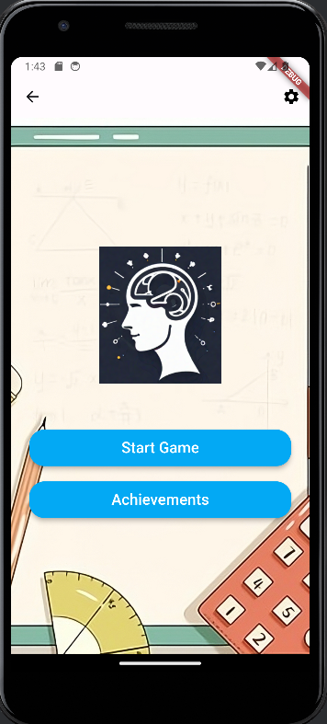

1. **Functional Requirement & Non-functional Requirements**
   1. **Functional Requirements**

| **Requirements #** | **Statement** |
| --- | --- |
| **Requirement-1** | **Design an intuitive and user-friendly interface.** |
| **Requirement-2** | **Ensure compatibility with various devices (smartphones, tablets, etc.).** |
| **Requirement-3** | **Provide various levels of difficulty to cater to different skill levels.** |
| **Requirement-4** | **Include a variety of math concepts, such as multiplication, subtraction, division, and more.** |
| **Requirement-5** | **Include a scoring system to track and display users' progress.** |
| **Requirement-6** | **Provide immediate feedback for correct and incorrect answers.** |
| **Requirement-7** | **Implement an awarding system.(e.g., Badges)** |

*Table 2 Functional Requirements*

* 1. **Non-Functional Requirements**

| **Requirements #** | **Statement** |
| --- | --- |
| **Requirement-1** | **Ensure fast and responsive performance, even on low-end devices.** |
| **Requirement-2** | **Design the game to handle a growing number of users and content.** |
| **Requirement-3** | **Ensure compatibility with various operating systems (iOS, Android, etc.) and screen sizes.** |
| **Requirement-4** | **Comply with relevant regulations, especially if the app is intended for educational purposes involving minors.** |
| **Requirement-5** | **Allow users to play the game offline.** |
| **Requirement-6** |  |
| **Requirement-7** |  |

*Table 3 Non-Functional Requirements*

*Phase Two*

1. **System models**

Modeling user interaction is important as it helps to identify user requirements. Modeling system to system interaction highlights the communication problems that may arise.

* 1. **context diagram**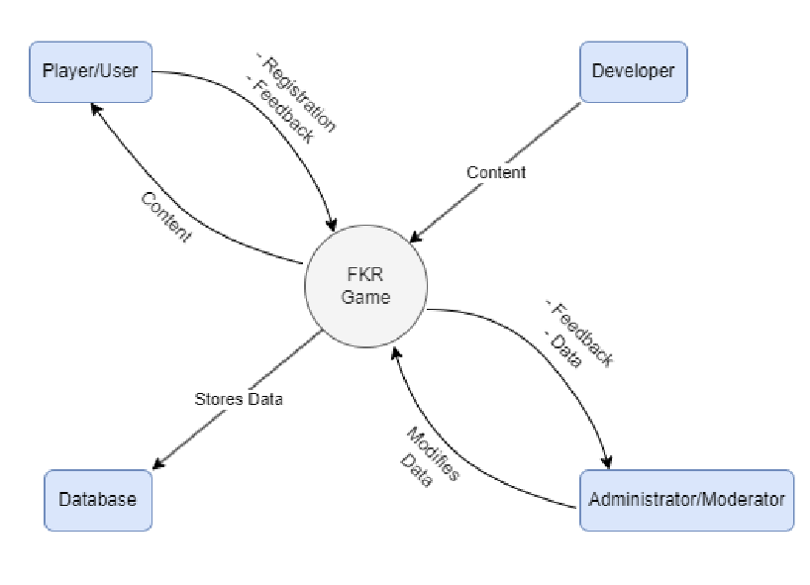
  2. **Use case diagram**

Use case modeling, which is mostly used to model interactions between a system and external actors (users or other systems).

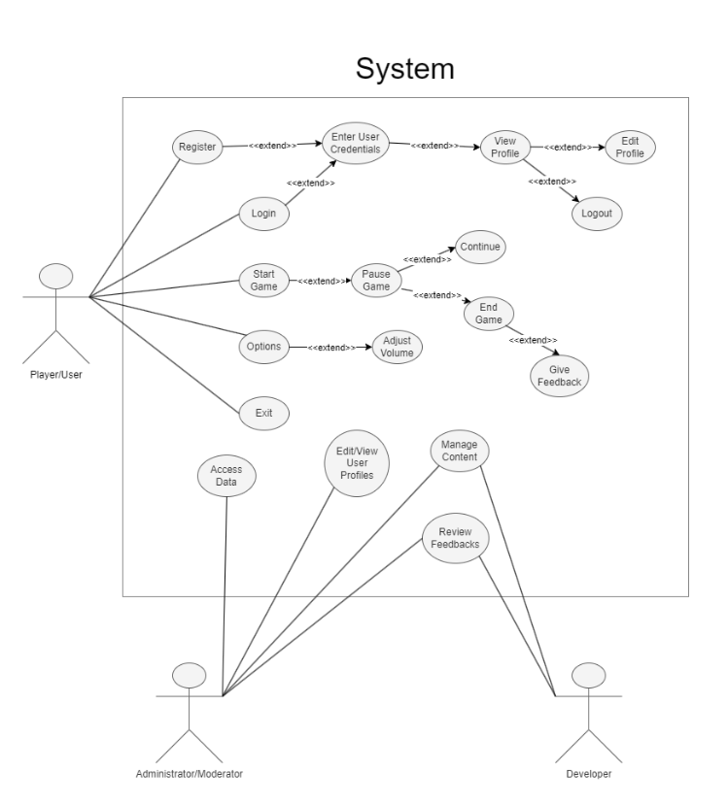

* 1. Sequence diagram
     1. Login sequence diagram

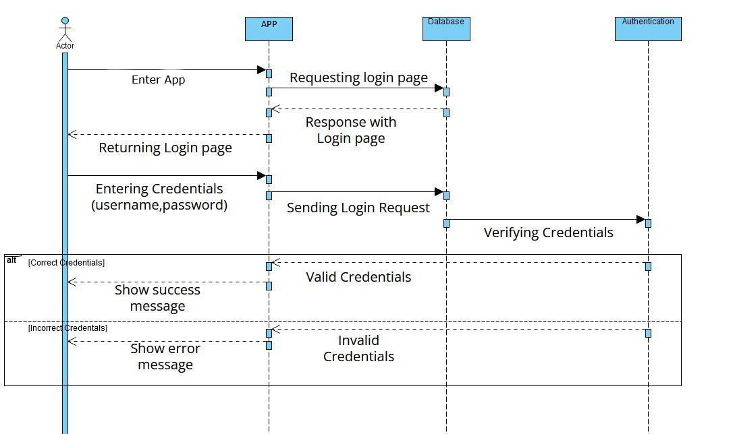

* + 1. Staff member manage content sequence diagram

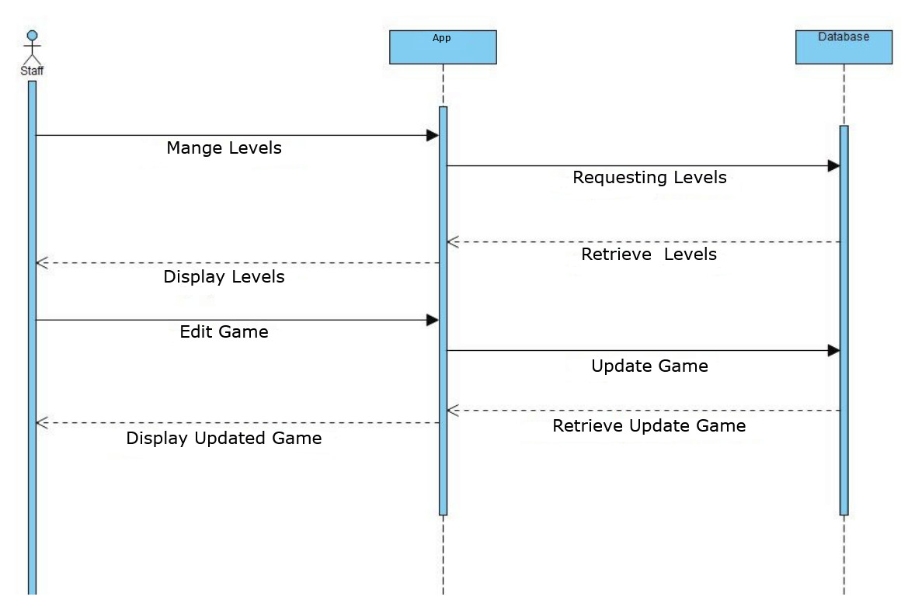

* + 1. Viewing Game sequence diagram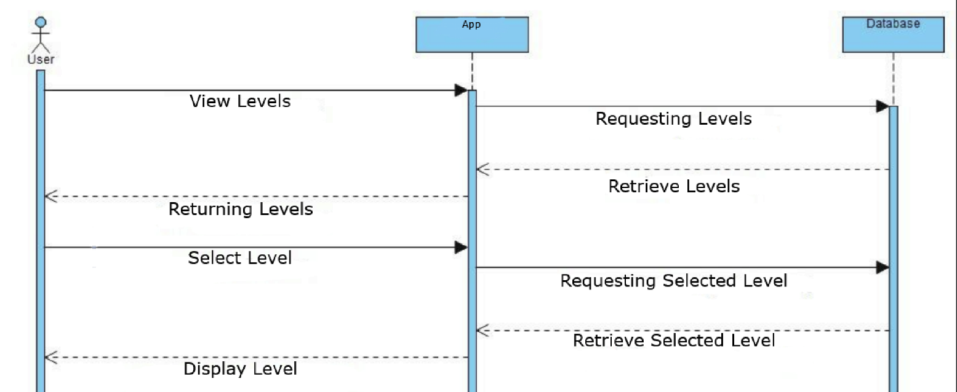
  1. Class diagram: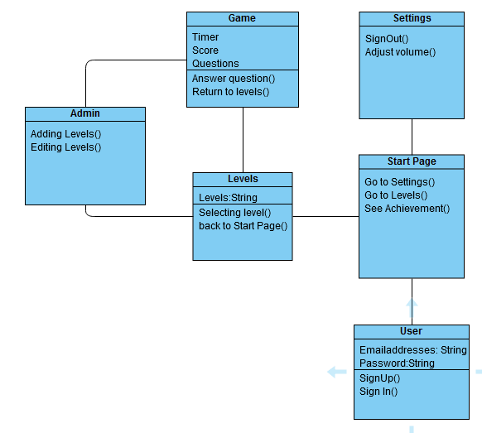
  2. Activity diagram
     1. Activity diagram (Login Page)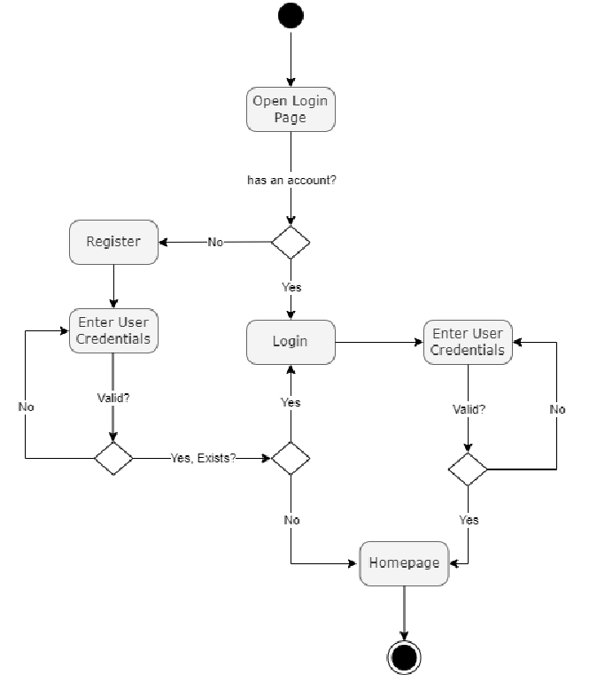
     2. Activity diagram (Game Page)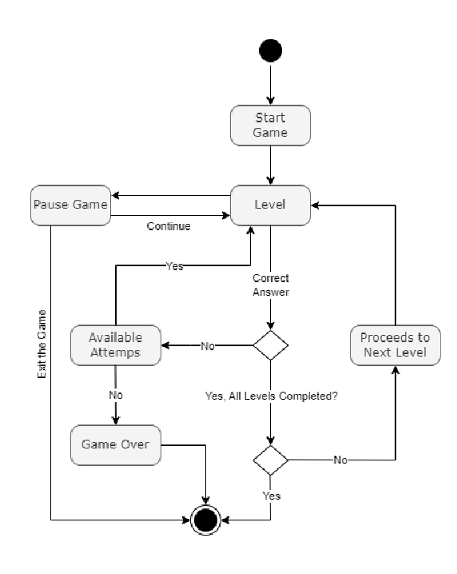

* 1. State diagram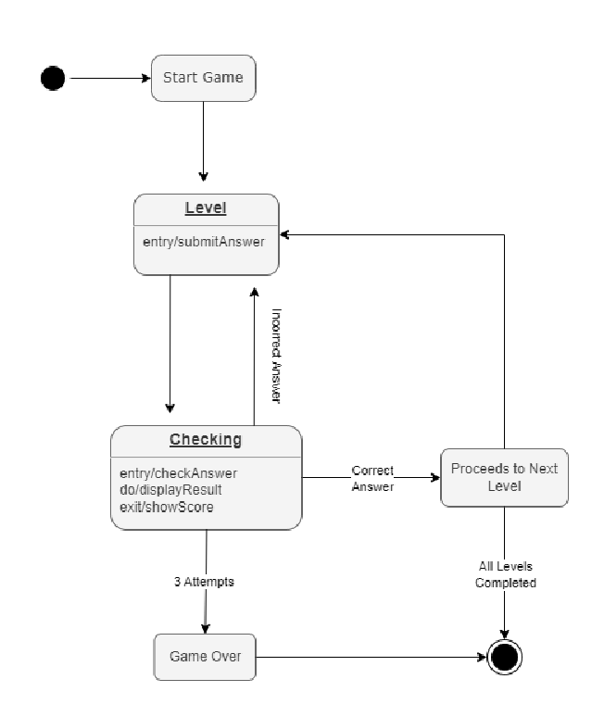

**2.User Interface Prototype**

A prototype is an initial version of the system. In which we used to demonstrate concepts and try out design options.

**2.1 User interface**

**2.2Login interface**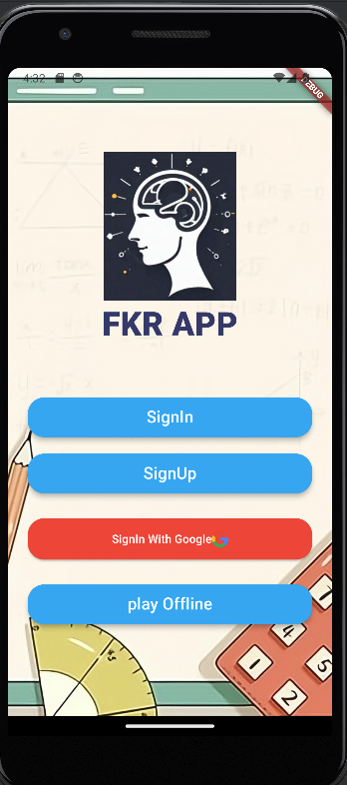

**2.3Levels Interface**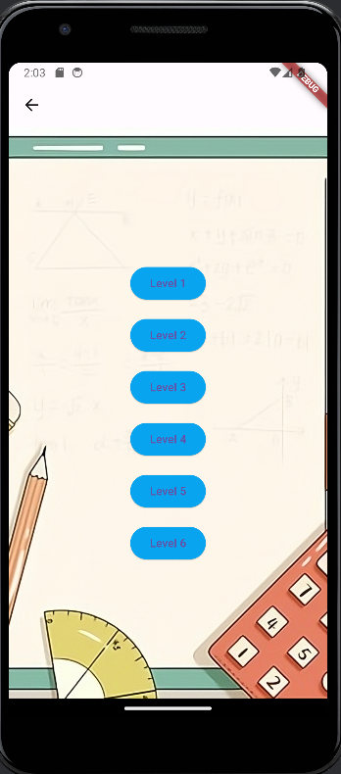

**2.4Game Interface**